Hilton, Milton and Castle Heather Community Council Meeting
4 August 2026 - 7.00 pm
Hilton Community Centre

1. Welcome from Chair
The Chair welcomed everyone to the meeting.
Present: Sarah Walker (Chair, Community Councillor), Aaron Taylor (Vice Chair, Community Councillor), Jess Maclennan (Treasurer, Community Councillor), Richard Allan (Community Councillor), Peter Wyness (Community Councillor), Shirley Wyness (Community Councillor), Steven Whitelock (Associate Member / minute taker), Angie Henry, James Geegan and Dian Aggrottini; Cllr Andrew Mackintosh, Cllr Jackie Hendry, Cllr Alasdair Christie, Cllr Ian Brown and Cllr Michael Gregson (Highland Councillors).
Apologies: Samson Odubanjo

2. Housekeeping
The Chair advised those present of a change to the meeting room layout, with seating arranged in a theatre-style format.

3. Previous minutes
The minutes of the previous meeting were considered. No further action or amendments were raised.

4. Vote - to elect Associate Member
Steven Whitelock addressed the Community Council regarding his application to become an Associate Member. A vote was held and the appointment was approved unanimously by those eligible to vote.

5. Guest - Ian Braker, Acting Strategic Lead (Waste Strategy & Operations)
Ian Braker addressed the Community Council and those in attendance on waste services and fly-tipping.
The possibility of providing a skip was discussed; however, this was not considered viable due to the risk of inappropriate public use. Members were reminded that residents can book the Council's free bulky waste collection service for eligible larger household items.
Mr Braker asked that specific postcodes and street names be provided where waste issues were being experienced, to help identify the scale and location of problems and determine an appropriately sized response.
Cllrs Christie and Gregson contributed to the discussion. James Geegan raised a question regarding repeat offenders. It was confirmed that where evidence identifying an address or individual is recovered from fly-tipped material, enforcement action is pursued.
The capacity of existing recycling facilities was also discussed. It was advised that there are currently no plans for a new recycling centre, although existing capacity pressures are recognised. A new facility could involve expenditure in the region of £6-8 million.

6. Correspondence report
Aaron presented the correspondence report to the meeting. Thanks to our secretary, Samson for preparing the correspondence report.
The full Correspondence Report is attached to these minutes as Appendix 1.
Arising from the report, it was noted that Aaron and one Highland Councillor would attend the forthcoming meeting with Cairn Housing.

7. Updates

Bin - Old Edinburgh Road
It was reported that the requested bin could not currently be provided. The situation will continue to be monitored.

Autumn Quiz
Following the success of the previous quiz, another quiz, provisionally themed around the "Three Witches", is being considered for the autumn. No date has yet been confirmed.

Interim elections - Autumn 2026
Members were advised that interim Community Council elections will take place in autumn 2026 and that vacancies will be available. The Chair encouraged members to spread the message within the community and encourage interested residents to consider standing.

Litter pick - 16 August
The Chair reminded those present of the Community Council litter pick taking place on Sunday 16 August at 2.00 pm.

8. Treasurer's report
The balance of the Hilton, Milton and Castle Heather Community Council account stood at £9,041.

9. Councillors' reports

Cllr Michael Gregson
Cllr Gregson provided updates on monitoring vehicle speeds on Old Edinburgh Road and repair works relating to the Milton pitches. An update was also provided in relation to the Tomatin fire and businesses without premises.

Cllr Ian Brown
Cllr Brown reported that Mackenzie Road had been swept and provided an update regarding grass cutting. Positive feedback had been received from residents.

Cllr Alasdair Christie
Cllr Christie reported that letters had been issued regarding overhanging branches. Updates were also provided regarding lighting at junctions and the replacement of damaged bollards. It was further reported that one eviction notice had been issued in connection with anti-social behaviour.

Cllr Jackie Hendry
Cllr Hendry submitted a written report providing updates on a number of local matters. The full report is attached to these minutes as Appendix 2.

Cllr Andrew Mackintosh
Cllr Mackintosh highlighted a burger evening taking place on 13 August. No further matters were reported.
Following completion of the Councillors' Reports, a short discussion took place regarding ongoing bus cancellations following concerns raised by members of the public. The Chair advised residents experiencing issues with bus services to follow the appropriate complaints procedure.

10. Discussion Points

Highland Local Development Plan - Call for Ideas
The Chair highlighted Highland Council's Local Development Plan Call for Ideas and encouraged members and residents to consider proposals relevant to the Hilton, Milton and Castle Heather area. Reference was made to Highland Council guidance on submitting ideas.
Ideas raised during the discussion included:
- bringing vacant or underused units back into use;
- exploring whether an advice centre or similar community service could operate from an empty unit at Hilton Community Centre;
- the view that additional housing development is not required within the HMCH area and that existing community needs and infrastructure should be prioritised;
- exploring demand for allotments, including possible container-based allotments;
- a designated cycle path on Balloan Road;
- potential removal or redevelopment of garages near Cauldeen Primary School, including possible additional parking or another use;
- community wellbeing initiatives and opportunities for community ownership and support, including raised beds;
- additional public benches to encourage community use of local spaces; and
- improved night-time lighting within public parks.
Members were encouraged to continue considering potential ideas for the local area.

11. AOCB
No other competent business was raised.

12. Date and time of next meeting
6 October 2026 - 7.00 pm at Hilton Community Centre.

Appendix 1 - Correspondence Report
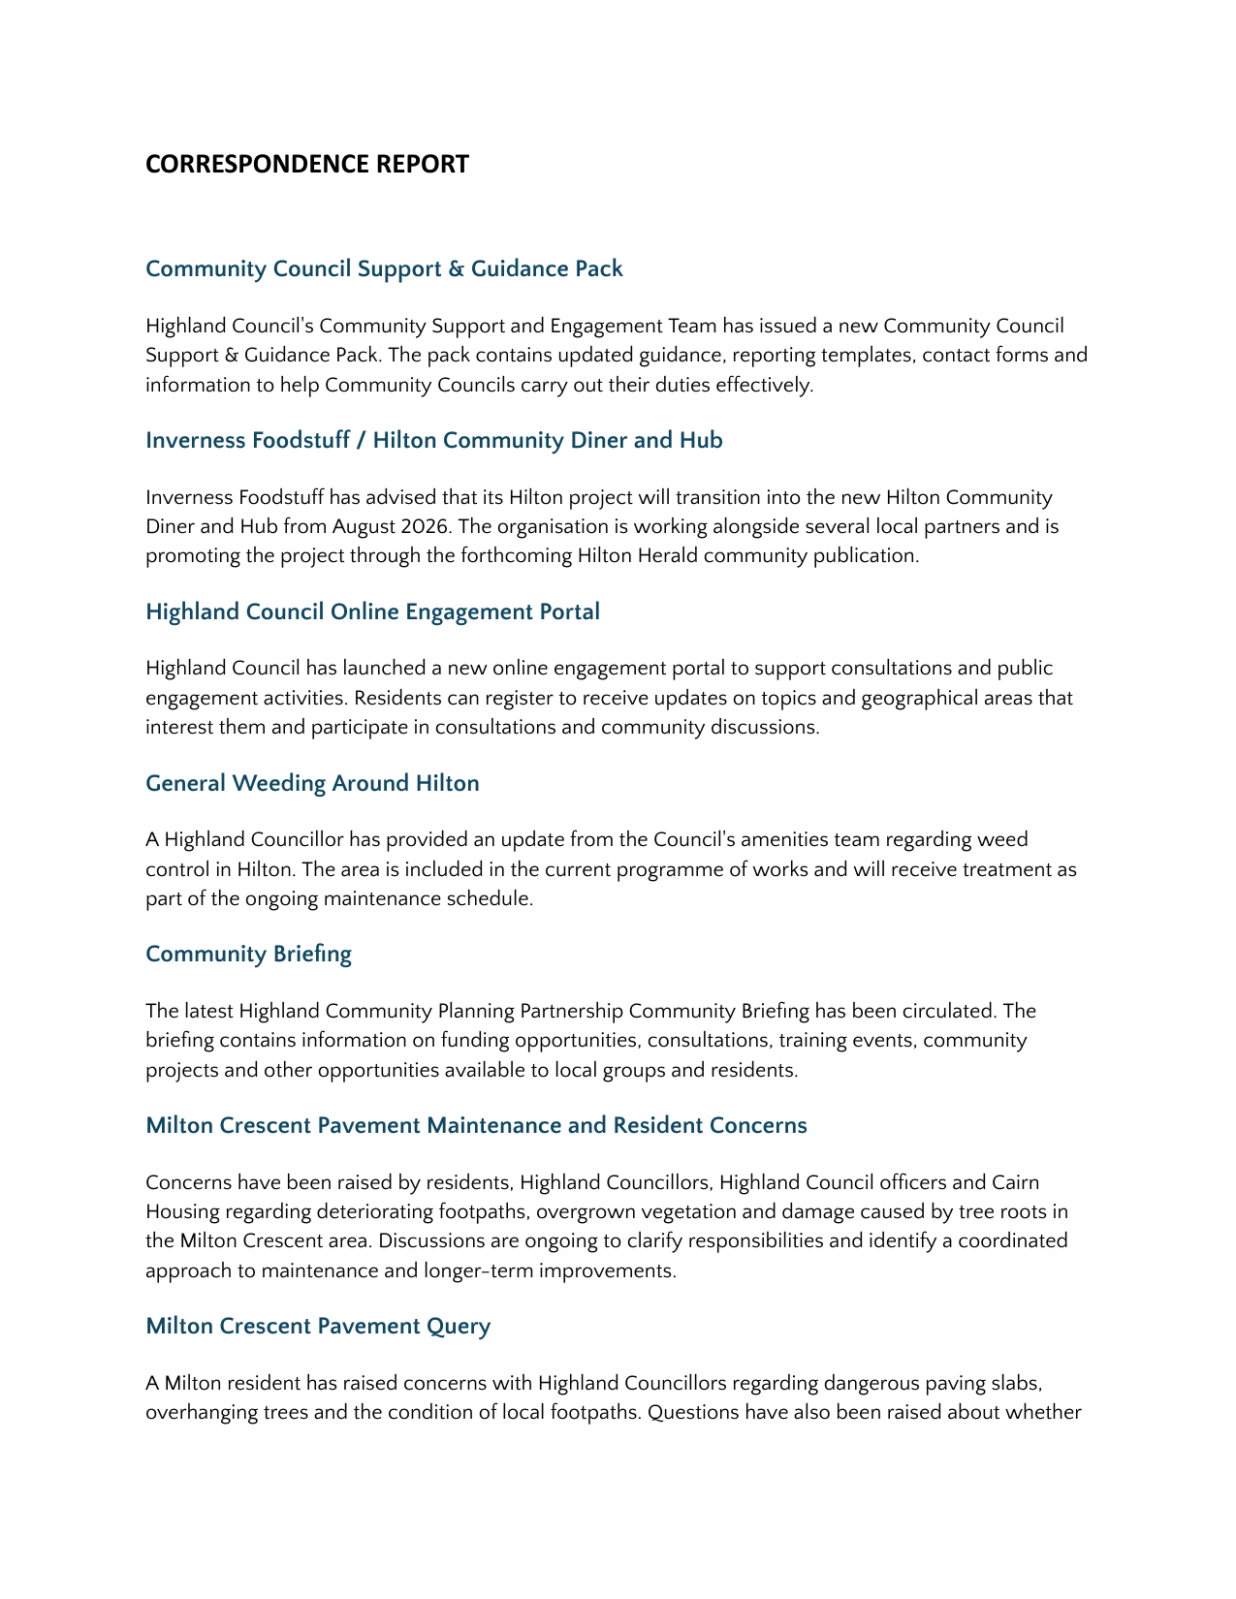

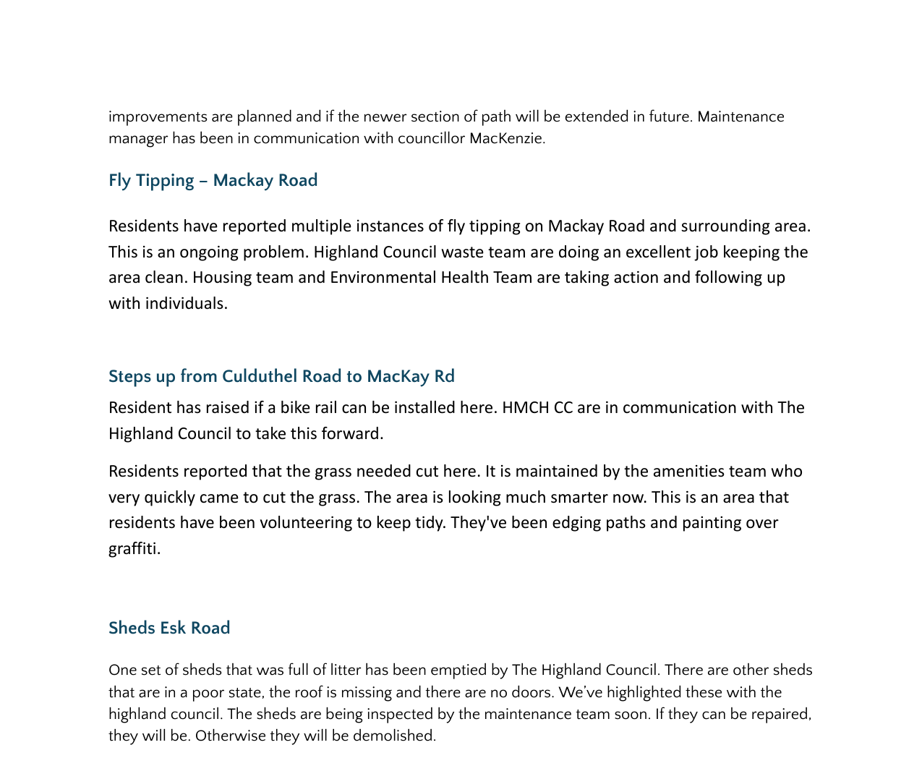

Sharp base of bin – Milton Pitches
This has been reported and The Highland Council are dealing with this.
Appendix 2 - Cllr Jackie Hendry's Report
